

Practices for Secure Software Report

Table of Contents
Document Revision History 3
Client 3
Instructions 3
Developer 4
1. Algorithm Cipher 4
2. Certificate Generation 4
3. Deploy Cipher 4
4. Secure Communications 4
5. Secondary Testing 4
6. Functional Testing 4
7. Summary 4
8. Industry Standard Best Practices 4

Document Revision History

Version | Date | Author | Comments
1.0 | [Date] | Alec Feldhaus

Client



Instructions

Submit this completed practices for secure software report. Replace the bracketed text with the relevant information. You must document your process for writing secure communications and refactoring code that complies with software security testing protocols.

- Respond to the steps outlined below and include your findings.
- Respond using your own words. You may also choose to include images or supporting materials. If you include them, make certain to insert them in all the relevant locations in the document.
- Refer to the Project Two Guidelines and Rubric for more detailed instructions about each section of the template.

Developer
Alec Feldhaus

Algorithm Cipher

The recommended algorithm would be AES with a 256-bit key as the primary archive-file encryption algorithm or AES-256. You may have seen this as the standard encryption of your WPA2 router security. The computing power to crack this level of encryption is too high to even warrant trying to crack one file’s encryption if the data was ever compromised, let alone the entire database. AES-256 is a recommended algorithm by Manico and Detlefsen (2014) for data at rest. It is also a semetrical key algorithm vs the RSA algorithms making it the more appropriate for data such as a file due to the smaller ciphertext that would need to be stored unlike the RSA algorithm that produces much larger ciphertext for the same bits and takes much more computational power and time to encrypt and decrypt. This could cause performance loss and adds the potential for a DoS attack due to the performance needs. The AES-256 is the better fit for long-term archive files where Artemis wants strong protection without creating unnecessary performance overhead.
To further demonstrate why this is the best algorithm, let’s first discuss government regulations and recommendations surrounding financial data. The Gramm-Leach-Bliley Act (GLBA requires financial institutions to implement safeguards to protect sensitive data. The encryption at rest satisfies this requirement. We should use the best balance of performance and security which AES-256 satisfies. We could have a 512-bit key for more security, but that would provide considerable overhead to decrypt. We could increase performance by using a 1 bit key with SHA-1 for a very light encryption that “technically” satisfies the requirement. However, this would almost certainly degrade customer trust and be a huge red flag in any security audit. More on this later. There are additional governmental regulations surrounding financial data such as the Federal Trade Commission requireimng a comprehensive information security program to protect consumer information and SEC regulations in a non-rewriteable, non-erasable format such as, Write Once Read Many (WORM). A signed ciphertext using something like AES-256-GCM would ensure that the data was never altered and ensure authenticated users only can decrypt and view the data, satisfying the WORM requirements of the SEC and other governmental restrictions above.
There are some risks to this recommendation, although they are few. The first, has been touched upon previously. It isn’t the most secure algorithm. An AES-512 algorithm may be more secure, but as mentioned before that creates an additional risk of performance overhead that could cripple the software and become an avenue of attack for a web application, increase costs of computational resources under normal operation, and is generally only reserved for the highest degree of secrecy required. If the archive storage is needed to be accessed by Artemis employees to service customers, this means the cipher would be used to encrypt and decrypt the data. This poses the risk that it is able to be decrypted if an attacker had access to the private keys. This is why key management is so important, what would have been nearly impossible to decrypt becomes a task measured in seconds to decrypt all financial data with a simple script if the attacker obtains the private keystore.
Finally, there are several security best practices that need to be considered to defend against certain attacks. First, there needs to be authentication of users accessing the system, obviously. Otherwise, the encryption at rest serves little purpose the system will just decrypt it freely for anyone that wants to see it. There needs to be file name and identifier validation to eliminate filepath attacks to attempt to obtain private keystores or other sensitive files, prevent executable files from being uploaded, log null bit intrusion detection, and more avenues of attack. Authorization policies help ensure the files can’t be accessed by unauthorized users as mentioned previously. File size limits and content limits need to also be enforced. This includes limiting executable files like jpx or war files. This also prevents zip bombs from being uploaded creating a DoS attack. Files should also be quarantined and virus scanned before being encrypted and upload to the database to ensure that they don’t spread malicious software. Additional security program best practices are strong key management to prevent attackers from getting private keys. Encrypting private keys is a potential avenue. Keys need to be rotated over time as well to ensure data at rest can’t all be compromised in a single attack. Even simple security like ensuring file resources are closed when no longer needed or an exception occurs prevents DoS attack avenues.
To justify my choice let’s discuss a few final items. Hash functions help verify the ciphertext hasn’t be changed. If the signature doesn’t match, decryption stops to prevent data tampering. AES includes an HMAC signing key that serves this purpose. Bit levels are the “strength” of the encryption. It serves as the number of possible combinations creating much more complexity and computing power to crack and dramatically less collisions (or two inputs that produce the same hash value). Random number generation is used in cryptographic algorithms. Random number algorithms themselves must be seeded for virtual true random numbers. However, seeds produce the same pseudo random numbers. Thus, java has implemented classes like SecureRandom that use platform agnostic ways of generating pseudorandom numbers for use in cryptography. AES is a symmetric algorithm meaning it can be used encrypt and decrypt data, which is the intended functionality for long term storage. Asymmetric cryptography requires a public key and private key better suited for communication between systems. AES is the more modern symmetric choice for protecting and storing sensitive data. RSA and DSA algorithms are great for other purposes like communication between the front end and backend of the system to have encryption in transit. DSA is great for signing certificates. Each algorithm has its place, and we need to pick the one that matches the threat model and operational needs for the task assigned. In the case of storing archive files at rest. AES-256 offers the strongest, most logical approach

Certificate Generation
Insert a screenshot below of the CER file.

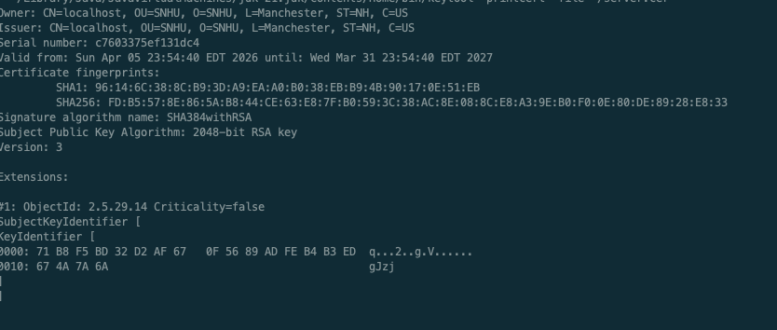

Deploy Cipher
Insert a screenshot below of the checksum verification.

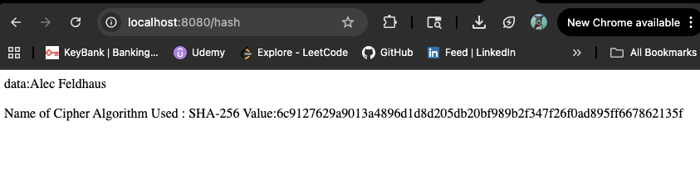

Secure Communications
Insert a screenshot below of the web browser that shows a secure webpage.
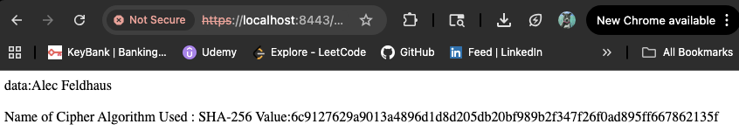

Secondary Testing
Insert screenshots below of the refactored code executed without errors and the dependency-check report.

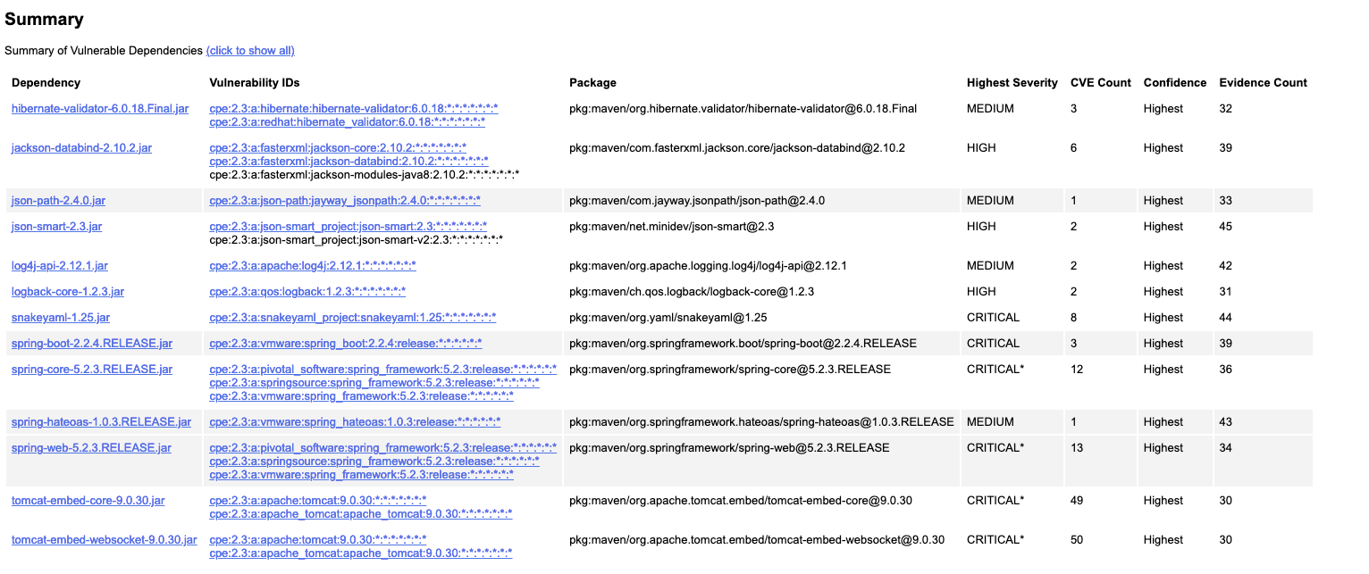
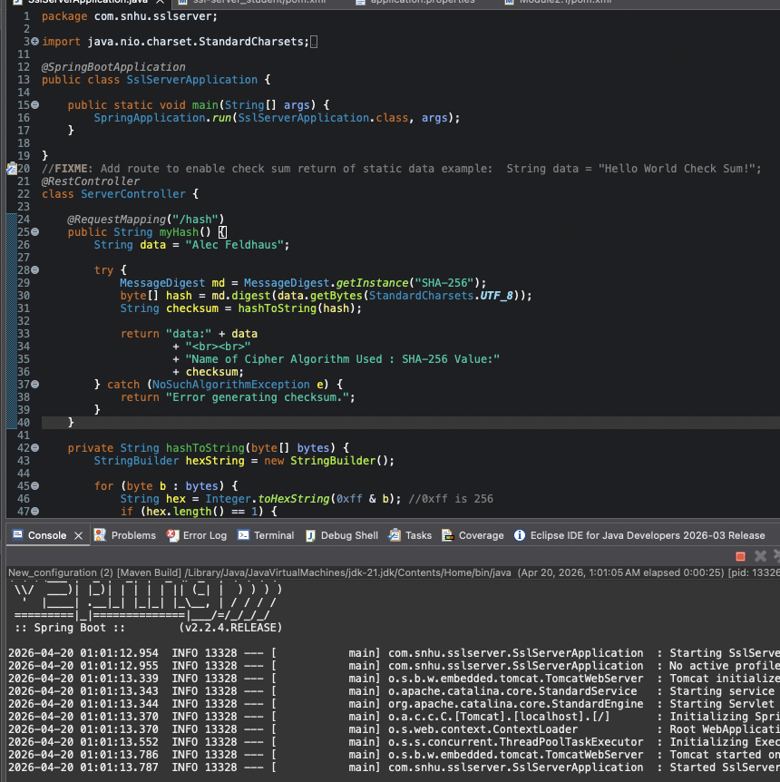

Functional Testing
Insert a screenshot below of the refactored code executed without errors.
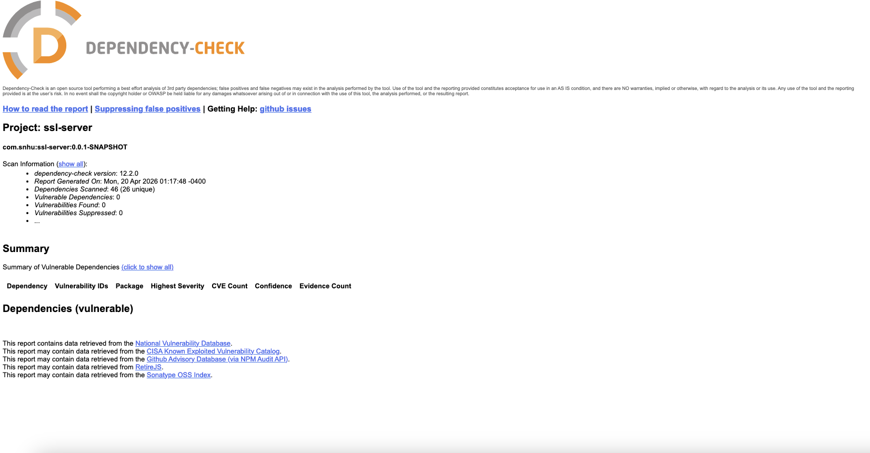
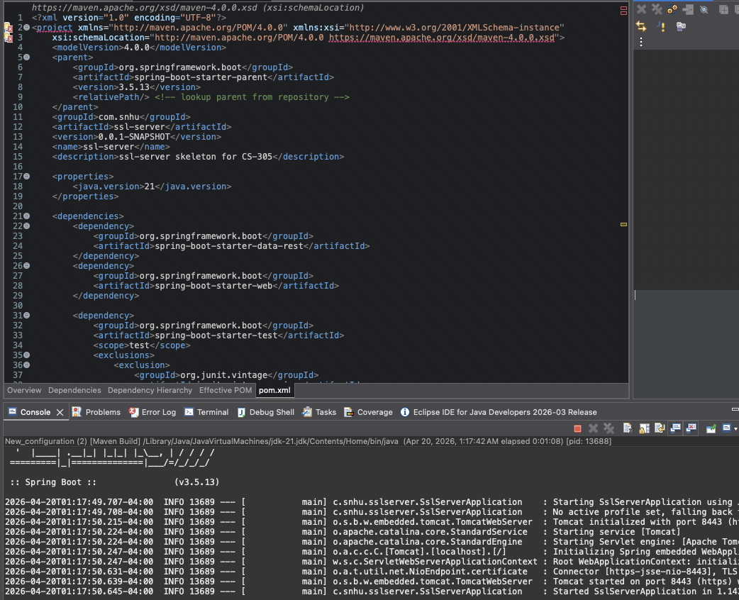
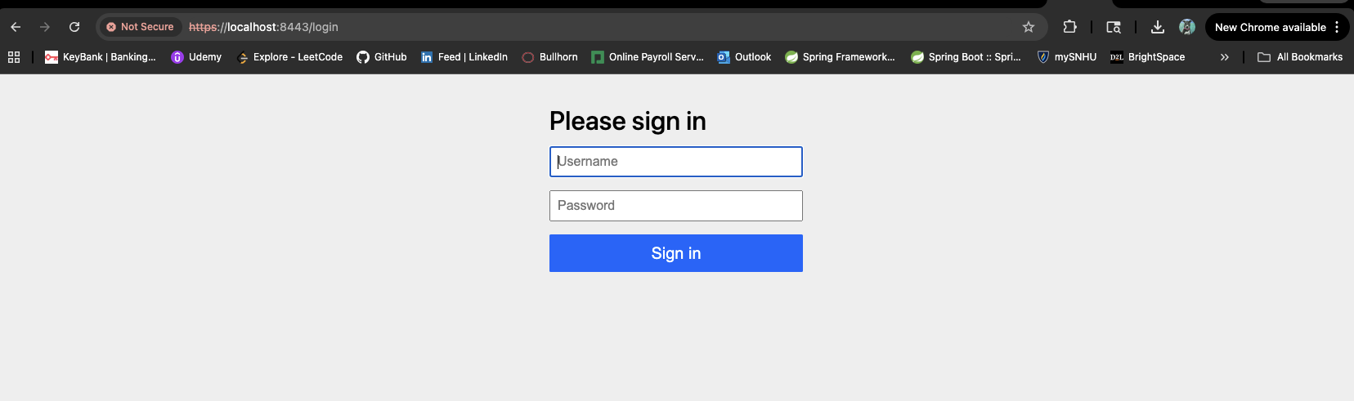

Summary

I refactored the code by working through the main parts of the vulnerability assessment process: identifying weaknesses, updating vulnerable components, improving secure communication, and then retesting the application to see what changed. The majority of that was upgrading the project to Spring Boot 3.5.13; A long-term stable version of springboot still receiving updates. I also added spring-boot-starter-security to build in another layer of protection for the application. On top of that, I updated the application properties so the app runs over HTTPS instead of HTTP, and I verified that secure communication was working by running the application and accessing the /hash endpoint through the browser. I also implemented the checksum feature so the application could support secure data verification during transfer.

My process for adding layers of security was basically to lock things down one step at a time and test as I went. First, I fixed the secure communication settings so the app would use SSL. Then, I ran the dependency scan to see what was vulnerable. Next, I upgraded dependencies, added Spring Security. After that, I reran the scan to check the results. That brought the project down to one remaining finding involving log4j-api-2.24.3. Based on the report, that CVE applies to the Socket Appender in Log4j Core, which this project is not using, so it does not appear to affect the actual runtime behavior of this application. Finally, I added logging. Logging is important because it can be one of the easiest and earliest points of identifying attack patterns. Overall, the refactoring addressed dependency security, transport security, and general hardening of the application, while following the basic process of identifying, fixing, and verifying vulnerabilities.

Industry Standard Best Practices

I applied industry standard best practices for secure coding by keeping the application’s existing security in place while also strengthening the areas that were weak. I did that by updating outdated and vulnerable dependencies instead of leaving the application on older versions, adding Spring Security for another built-in layer of protection, enabling HTTPS so data is transmitted securely, and implementing the checksum feature to support data verification. I also added logging so there is a record of requests and application behavior without exposing sensitive information. Another important part of following best practices was testing after each change instead of just assuming the fixes worked. I used the dependency scan results to identify known vulnerabilities, refactored the code and configuration to address them, and then reran the scan to verify that the application was more secure. That helped maintain the software’s existing security while improving the parts that were outdated or more exposed.
The value of applying industry standard best practices is that it helps protect both the company and its users over the long term. For Artemis Financial, that matters a lot because the application handles client and financial information, so weak security could lead to data exposure, loss of trust, and damage to the company’s reputation. Using secure coding best practices helps reduce those risks by lowering the number of known vulnerabilities, protecting data during transmission, and making the application easier to monitor and maintain. It also puts the company in a better position going forward, because secure coding is not just about fixing one problem at a time. It helps create a stronger foundation so future updates, testing, and security improvements can be handled more safely and consistently.

